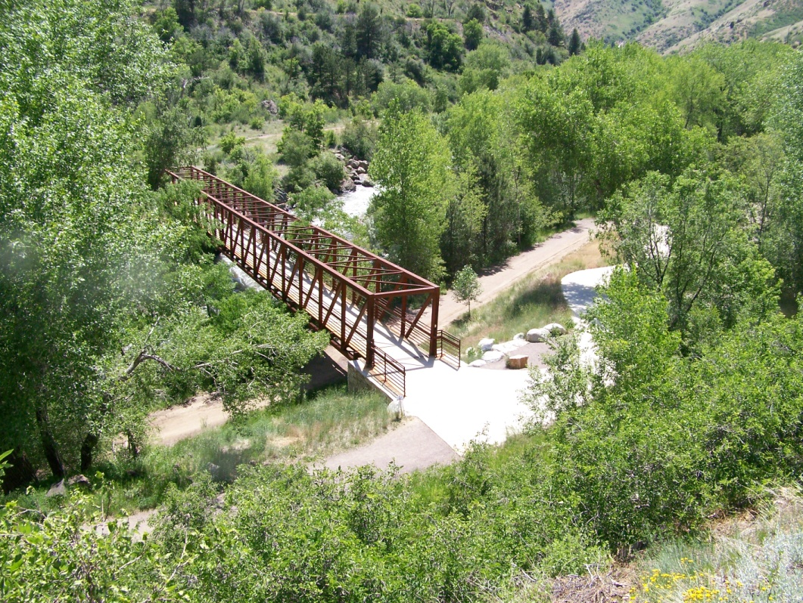
U.S. 6 Trail Bridge. NCCMAC plans to build a multi-use trail as part of the Main Street South Project on Highway 119 that will eventually tie in with the Jefferson County Open Space trails off of U.S. 6.
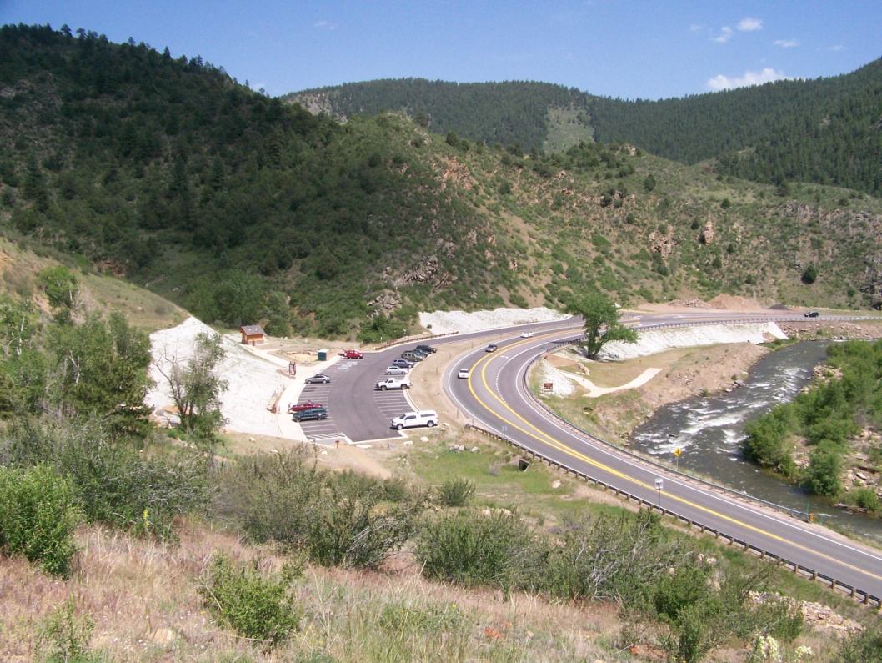
Dozens of recreation enthusiasts visit the Mayhem Gulch Trailhead daily off of U.S. 6.

